|  |  |  |  |  |  |
| --- | --- | --- | --- | --- | --- |
| Date | 29-Nov-22 | | | Tester Name | Andrew McLaughlin |
| Environment | Penfax - Test | | | Login used |  |
| Operating System | Select OS | Version: | Update: | | |
| Software Used | Select Software | Version: | Update: | | |
| Select Software | Version: | Update: | | |
| Release version | 22.4.1 | | | | |
| Title | Death – Single GP not expired Beneficiary named | | | | |
| Test Type | Regression | | | | |
| Test Scenario | Death – Single GP not expired Beneficiary named | | | | |
|  |  | | | | |
| Expected Results | When a pensioner dies with a beneficiary named, their remaining payments should be paid out to the beneficiary.   * We should be able to transfer the income benefit to the beneficiary with an expiration date equal to the guarantee period. | | | | |
| Pass/Fail | Pass | | | JIRA# | N/A |

Describe your steps with screenshots:

Member has beneficiaries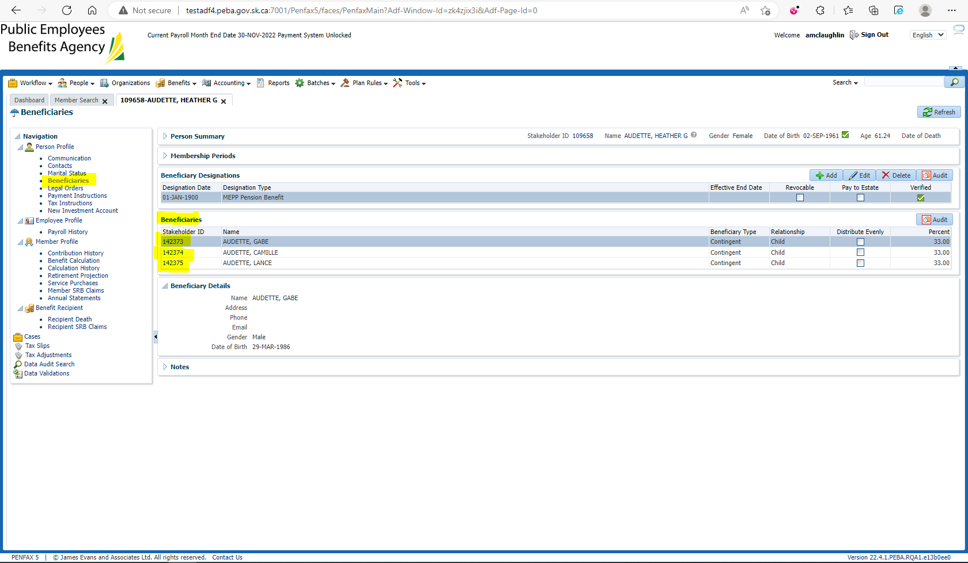

Pension amount is $4,410.34 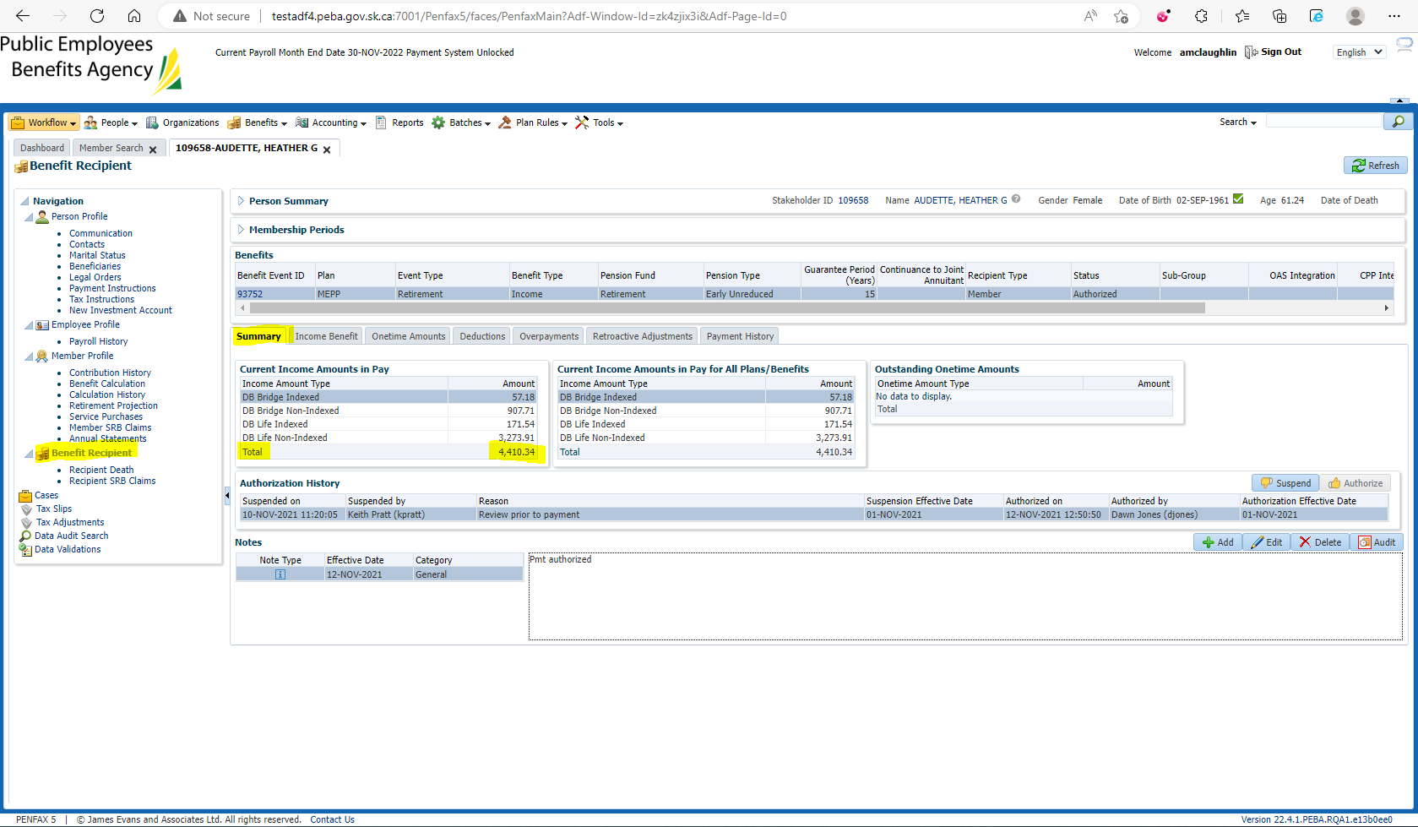

Enter Death Date 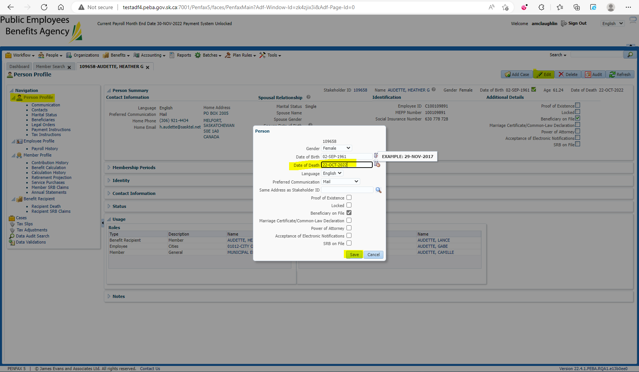

Add the beneficiary to the Benefit Recipients in the Benefit Event effective 1st day of month after death 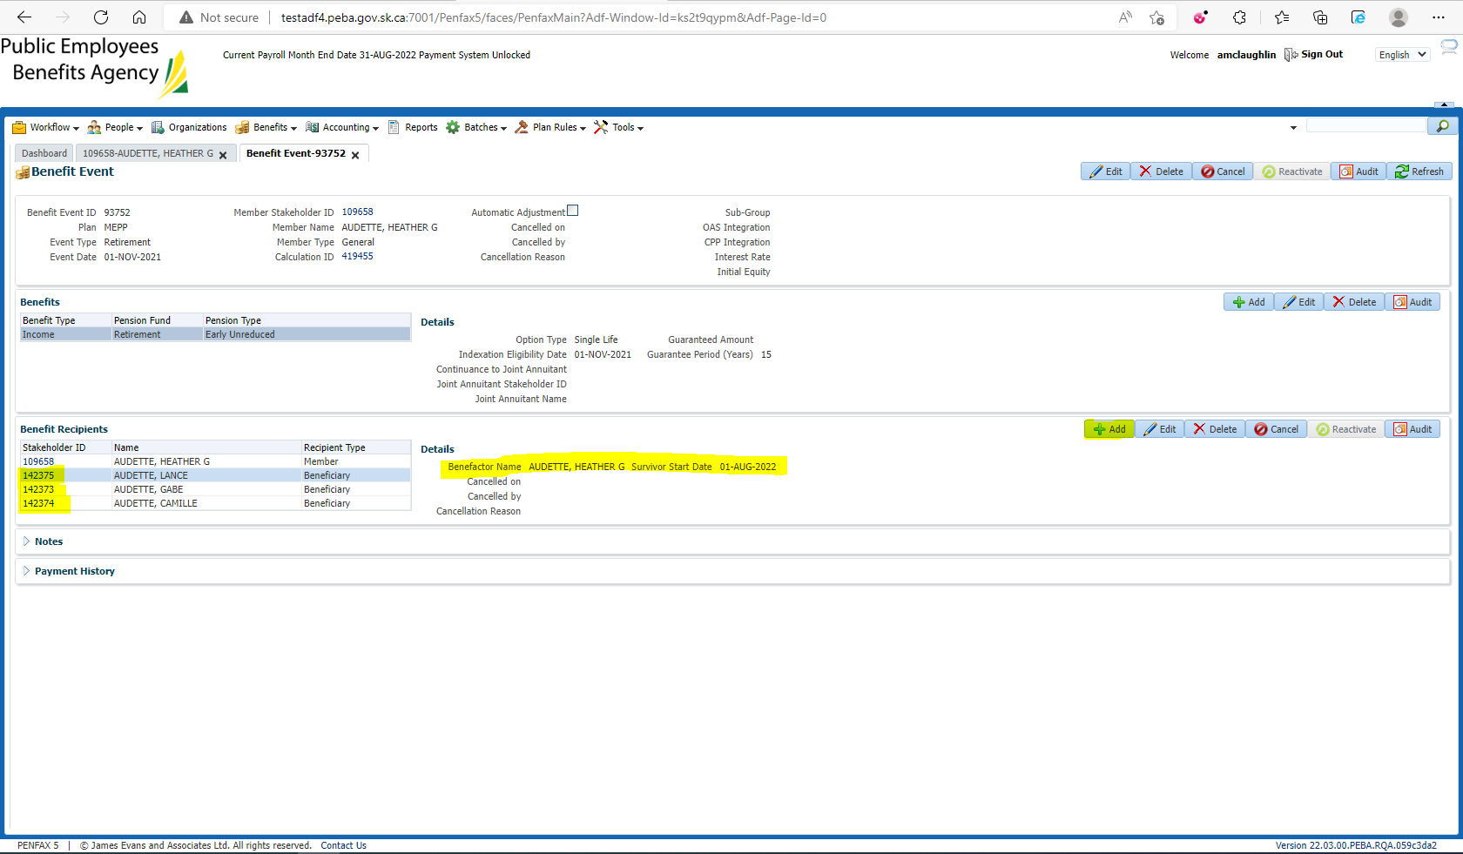

Open the Death Calc 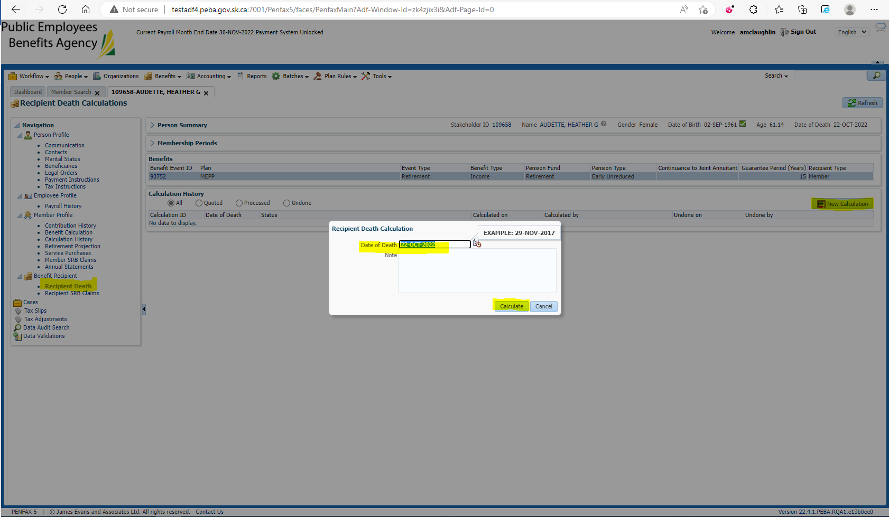

Process x2 and Process Recipient for each beneficiary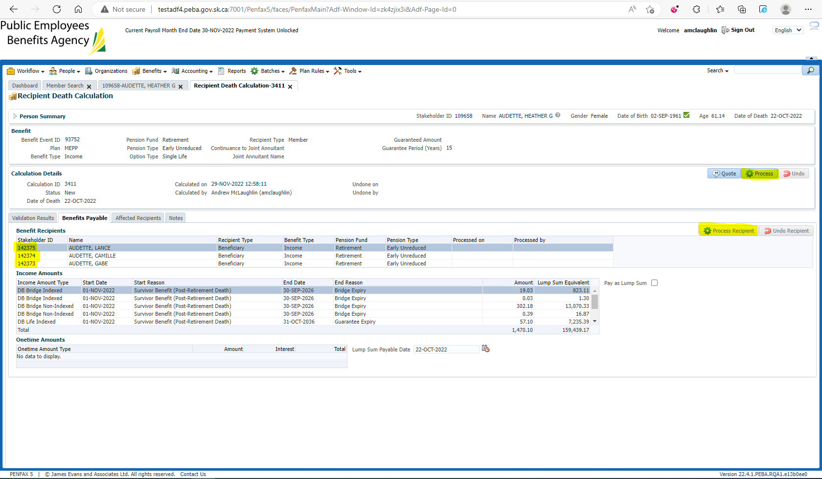

Verify under the beneficiary’s Benefit Recipient that the pension amount is correct 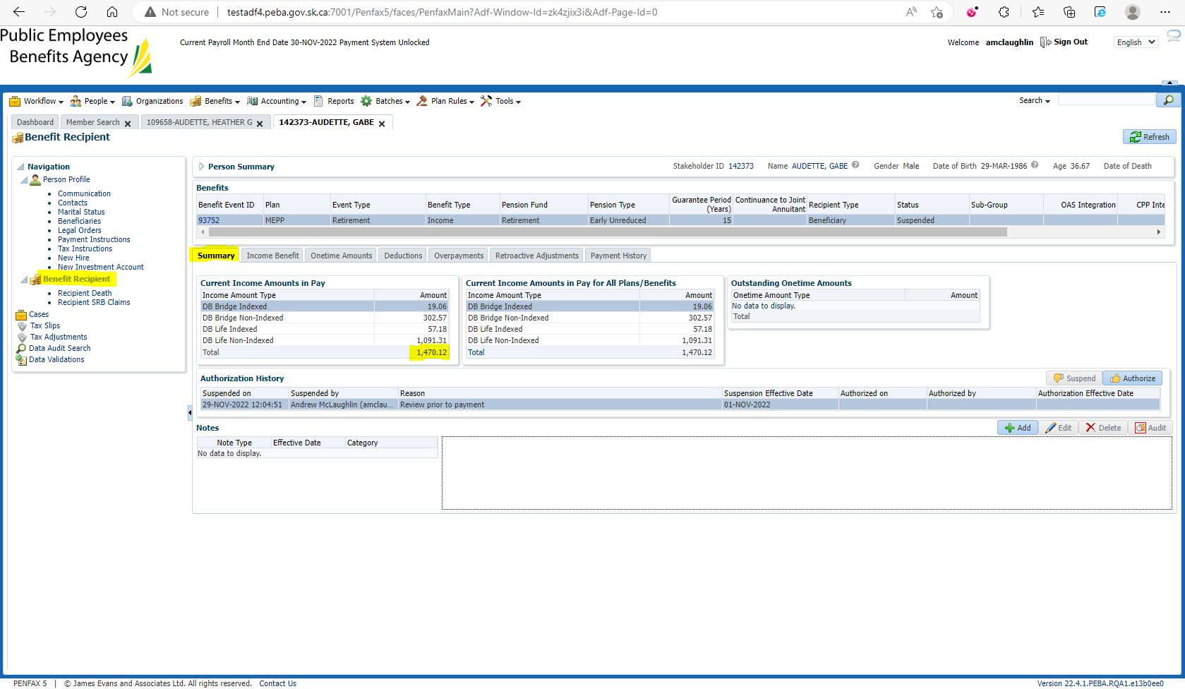

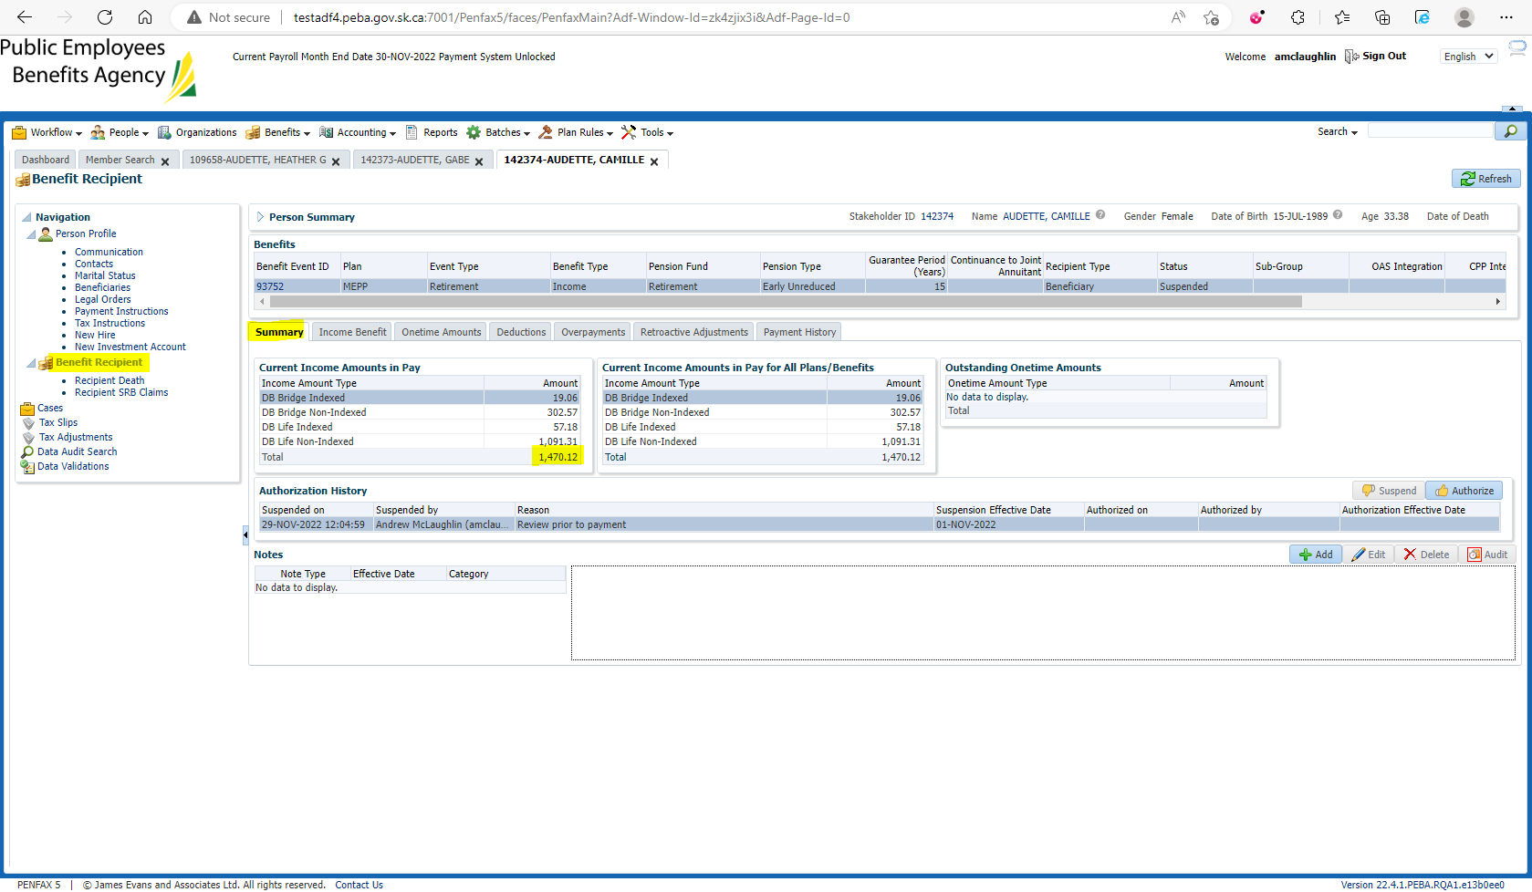

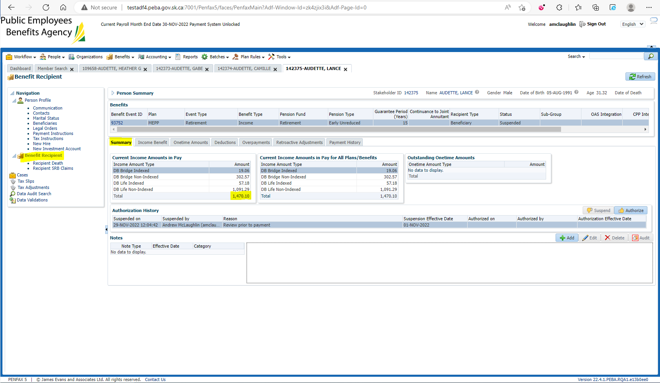

$1,470.10 + $1,470.12 + $1,470.12 = $4,410.34